PROJECT DOCUMENTATION / MODEL TRAINING

I. Training Pipeline Architecture
Hotel cancellation probability at T−14 | Separate modelling for H1 Resort and H2 City
Purpose. This document explains the training architecture in plain language: how booking data is prepared, how candidate models evolved through development experiments, what evidence supported the shortlist, and what the final training workflow will deliver.
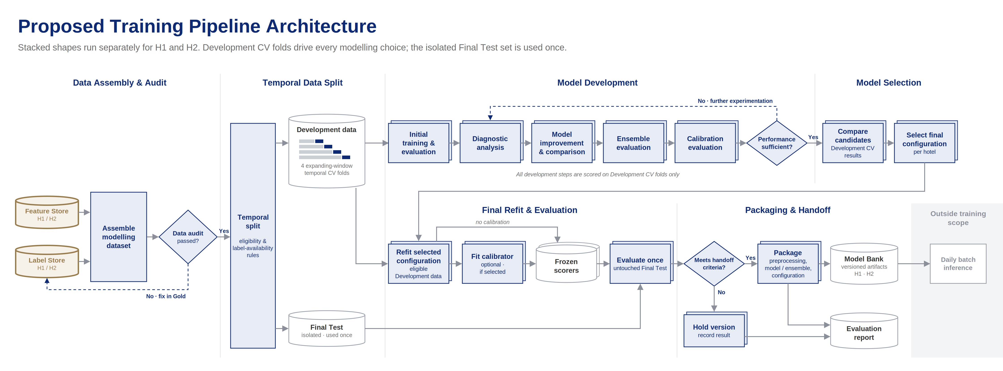
Figure 1. Training pipeline roadmap. Final refit, Final Test evaluation and model handoff follow Development model selection.

Pipeline Overview
Inputs & task | How development works | What the pipeline delivers
Gold booking features and cancellation labels; output = one risk probability per booking, scored at T−14. | Separate H1/H2 models; four expanding-window temporal CV folds; models compared using both probability and daily-forecast metrics. | Select model/ensemble configuration, refit on eligible Development history, evaluate once on held-out Final Test, then version and hand off frozen scorers.

PROJECT DOCUMENTATION / MODEL TRAINING

II. Data Preparation & Initial Modelling
Data assembly, temporal validation, baseline training and diagnostics

1. Data Assembly & Audit
For each hotel, Gold Feature Store records and Label Store outcomes are joined one-to-one by Booking_ID. Each modelling record represents a booking at T−14, with Gold predictors, an observed cancellation/no-show label, and metadata such as Hotel and CutoffDate. The audit checks keys, labels, schema and predictor availability; outcome/status fields are not model inputs.

2. Temporal Data Split & Preprocessing
Split v2 reserves the Final Test cohort (18 Apr–17 Aug 2017) and uses four expanding-window time-based validation folds within Development. At each fit date, training uses only earlier bookings whose labels are available and whose expected stays have finished (Complete Follow-up Rule). Imputation, encoding and scaling are learned on eligible Train rows, then reused on Validation.

3. Initial Model Training & Evaluation
Model label | Full model / meaning | Role in first comparison
Dummy | Constant-probability baseline based on the training cancellation rate. | Reference: does a trained model beat a simple historical rate?
LR30 | Logistic Regression using the 30 original Gold predictors. | Simple linear, interpretable probability model.
RF30 | Random Forest classifier using those same 30 Gold predictors. | Non-linear tree ensemble; strongest initial Log Loss result for both hotels.
XGB30 | XGBoost gradient-boosted trees using the same 30 predictors. | Strong non-linear alternative; later useful in ensemble evaluation.

Model naming: “30” denotes the 30 original Gold predictor features, not the number of trees or a separate algorithm. Engineered features, when tested, were added to this base feature set.

4. Diagnostic Analysis
After initial comparison, the team examined differences between Train and Validation performance, shifting cancellation rates over time, probability reliability, segment-specific errors and high-error arrival days. H2 showed notable temporal instability and probability overprediction, motivating targeted feature and training-strategy experiments rather than simply trying more models at random.

Evaluation Metrics
Primary metric: Log Loss assesses the accuracy of booking-level cancellation probabilities. Business-facing checks: Daily nRMSE and Daily Bias % evaluate daily cancellation counts obtained by summing those probabilities. Additional metric: ROC-AUC measures risk ranking. All selection evidence comes from Development CV.
PROJECT DOCUMENTATION / MODEL TRAINING

III. Model Development Experiments
Controlled model improvements, ensembles and probability calibration

5. Controlled Experiment Screening
Improvement area | What was actually tested | What the screening showed
Recency weighting | Random Forest with more weight on recent bookings: RW90, RW180 and RW365 denote exponential weight half-lives of 90, 180 and 365 days. | RW365 gave H1 a small Log Loss gain; RW90 and RW180 were promising for H2.
Feature engineering | Extra predictors added to the original 30: segment-relative LeadTime, segment × LeadTime, group-related interactions (FE3) and historical segment cancellation rate (FE4). | FE3 gave only modest H1 improvement. FE4, built from past available labels, improved H2 across all four folds.
Model regularization | Changed Random Forest tree depth / minimum leaf size (including RF-T4 and RF-T5); also checked stronger regularization and convergence for Logistic Regression. | Less complex RF helped H2 generalization; LR improved but remained less competitive.
Model alternatives | Tested LightGBM, CatBoost and TabM (a deep-learning architecture for tabular data), in addition to the initial RF/XGBoost candidates. | CatBoost was competitive on H1 bias. TabM with 8 training epochs (TabM-E8) had strong H2 daily forecasting; longer runs worsened validation.

6. Combined Improvement Experiments
H1: Combining 365-day recency weighting with FE3 group interactions did not beat the standalone weighted Random Forest. H2: Two leading configurations emerged: C2 = Random Forest + RW180 + FE4 (historical MarketSegment cancellation rate); C4 = regularized Random Forest (RF-T5, max depth 12 and minimum leaf size 40) + RW90. These are configurations of Random Forest, not new model families.

7. Ensemble Evaluation
H1-E2 = RF30 + XGB30 with 50/50 probability averaging. H2-E1 = C2 + TabM-E8 with 50/50 averaging; H2-E4 = C2 + C4 + TabM-E8 with one-third weight for each. Equal-weight ensembles improved Development scores. Temporal learned weights were tested but did not generalize reliably, so they were not retained.

8. Probability Calibration
For the six shortlisted solutions, the team compared unchanged probabilities with Sigmoid and Isotonic calibration mappings. Each mapping was fitted from earlier eligible out-of-fold predictions, then evaluated on later folds (F2–F4). Calibration introduced no new base classifier; it was an optional post-processing step. Neither method improved mean Validation Log Loss, so the shortlist remains uncalibrated.
Data caveat. Historical booking snapshots are unavailable; the 30 Gold feature values are assumed to reflect information available at T−14, which cannot be fully verified retrospectively.
Evidence: model_development notebook (Sections 0–9), Gold modelling data/split artifacts and the Training Pipeline Architecture. Final refit, Test and handoff are next-stage workflow, not evaluated results.
PROJECT DOCUMENTATION / MODEL TRAINING

IV. Model Selection
Development CV comparison of shortlisted single models and ensembles

9. Final Candidate Comparison
The table expands every model code into its component models or training changes. Figures use original uncalibrated four-fold Development CV, not unseen Final Test performance.
Hotel | Configuration in plain English | Log Loss ↓ | Daily nRMSE ↓ | Interpretation
H1 | RW365 — Random Forest on 30 Gold predictors; recent training bookings receive greater weight (365-day half-life). | 0.2612 | 0.9534 | Best shortlisted H1 single model.
H1 | H1-E2 — equal average of RF30 (Random Forest) and XGB30 (XGBoost), both using 30 Gold predictors. | 0.2586 | 0.9038 | Improves Log Loss and daily forecasts vs RW365.
H2 | C2 — Random Forest with RW180 recency weighting plus FE4 historical MarketSegment cancellation-rate feature. | 0.3462 | 0.9895 | More stable Log Loss across folds; strongest F2–F4 Log Loss.
H2 | C4 — regularized Random Forest (RF-T5) with RW90 recency weighting on the 30 original predictors. | 0.3457 | 0.9543 | Best shortlisted H2 single by four-fold Log Loss.
H2 | H2-E1 — equal average of C2 (weighted RF + FE4) and TabM-E8 (tabular deep learning, trained 8 epochs). | 0.3449 | 0.9244 | Two components; best H2 daily nRMSE among shortlist.
H2 | H2-E4 — equal average of C2 + C4 + TabM-E8 (two RF variants and one TabM). | 0.3446 | 0.9316 | Lowest H2 mean Log Loss; three components.

Comparison: For H1, E2 lowers Daily nRMSE by about 5.2% relative to RW365 and improves Log Loss in three of four folds. For H2, E4 has the lowest mean Log Loss, only 0.0003 lower than E1; E1 has better Daily nRMSE and fewer components, while C2 is more stable across folds. These are Development results, not Final Test results.

V. Final Refit, Test Evaluation & Handoff
Stage | Next pipeline output
Configuration lock + refit | Choose one solution per hotel; refit selected preprocessing and model/ensemble components on label-eligible Development data at the final fit date (18 Apr 2017). No calibrator is needed for the current shortlist.
One-time Final Test | Freeze the H1/H2 scorers, evaluate once on isolated future Test bookings, and report Log Loss, Daily nRMSE, Daily Bias %, ROC-AUC and reliability.
Versioned handoff | Package fitted preprocessors, trained components, ensemble averaging rules, feature schema, configuration and evaluation report for later batch inference.

